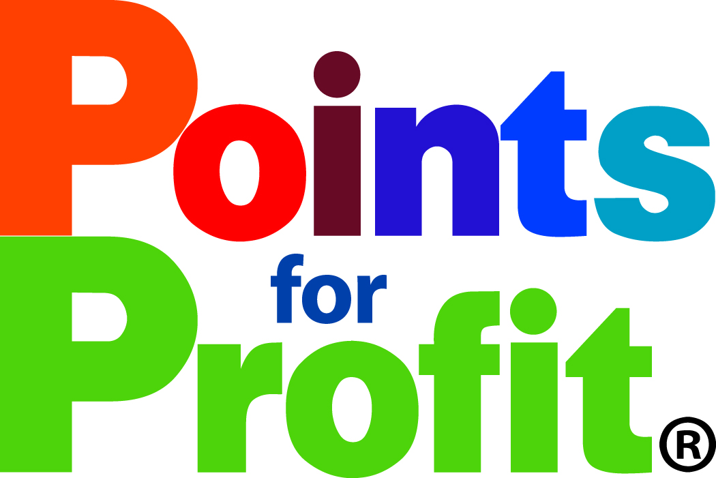**Business Bonus Points**

**Shop locally, serve locally and sustain locally!**

**All receipts receive the following:**$49.99 and under = one million $500 - $999.99 = 20 million

$50 - $99.99 = five million $1000 and up = 40 million

$100 - $499.99 = ten million

** = Additional fundraising opportunity**

**= Home-based business**

**1st Hand Seconds Unique Boutique and Chic-ee Chic-ee Bridal Boutiquee** Receive two million points for a donation (per donation, not per item). (Business is NPO Donations)

**AA Bowman Lock and Key/The Lock Doctor** Stop in and get your keys made, locks changed. Get five million for any quote for new locks and ten million for any safe purchased.

**Albany Animal Hospital** Receive 20 million points for becoming a new patient and ten million points for any appointment after the initial new patient appointment.

**Albany Golf and Event Center (Springhill)** 10 million points for signing up for any membership and 5 million per month maintaining memberships (Golf or Fitness). 20 million points for Booking and Holding your Event.

**Albany Visitors Association** Receive ten million bonus points for every hotel/motel room receipt in Linn County – 20 million for any hotel or motel event reservation in Linn County.

**Anytime Fitness Lebanon** Receive ten million bonus points for signing up for membership. Receive five million points for each continued month and receive an extra one million for each class you attend.

**AT&T – Spring Mobile** Receive five million points for purchasing any cell accessory. Sign up for AT&T and receive ten million bonus points and two million bonus points a month for any ongoing service (must be a minimum of six months to receive bonus)! (Make sure to include in Heritage Mall receipts also, DOUBLE POINTS)

**Beggs Tire and Wheel Receive** five million points for any written quote received. Receive 20 million points for a set of four tires or wheels purchased.

**Bigfoot Bites** Five million points for Bigfoot Burger or Baby Bigfoot Burger. Five Million for ordering dessert. (Make sure to include in Heritage Mall receipts also, DOUBLE POINTS)

**Bi-Mart Stores & Pharmacy Your 2010, 2011, 2012, 2013, 2014, 2015, and 2016 Large Business of the year!** Get five million bonus points for attending any Bi-Mart sponsored event.  Receive five million bonus points for each Bi-Mart Pharmacy receipt.

**Browsers’ Bookstore** Receive ten million points for every rare book purchased – five million for appraising the value of a book.

**Burgerville **Receive one million points for any meal basket purchased. Earn 20 million points for signing your organization up for a fundraising night at Burgerville.

**Butler Computer Services** Receive ten million points for signing up for computer services and 5 million for each month of continued service.

**Cadwell Realty Group** Receive ten million points for any referral. Receive 40 million points for listing or buying a home with them.

**Cascade Performing Arts Center** Five million points for checking out a dance class (It’s Free). Five million points for each month of classes you participate in. Ten million for each month of summer classes!

**City and Suburban Electric** Get a customized quote and receive five million bonus points. Receive ten million points for any referral and 20 million bonus points for any signed contract to do business with them.

**Chris Craig Productions** Refer a friend or business who uses their service and receive five million bonus points, schedule a consultation/quote and receive 20 million bonus points and receive 40 million for retaining their services for any video production.

**CoEnergy Propane** Get a customized quote and receive five million bonus points. Receive ten million points for any referral and 20 million bonus points for any signed contract to do business with them.

**Complete Business Solutions** Five million bonus points for free evaluation, five million bonus points for referring any customer who uses their services, ten million bonus points for signing a contract and receive an additional five million bonus points per month for ongoing monthly service!

**Country Financial Insurance** Michelle Morford - Receive five million points to quote a policy for you. Receive ten million points for each referral. Receive five million points for each continued month of service. (Make sure to include in Heritage Mall receipts also, DOUBLE POINTS)

**Cronies Antiques and Collectables** Receive five million bonus points for each purchase totaling $20 or more.

**Custom Eyes** Receive 20 million bonus points for any eye exam appointment. Ten million bonus points for any eyewear purchased.

**Dream Trips with Kevin Ryan** Receive 20 million points to host a party, ten million points for each party booked from your party. Receive ten million for signing up for services and two million points per month for monthly order/memberships.

**Dryer Vent Wizard of the Valley** Receive ten million points to get your dryer vent inspected and 20 million points for a vent cleaning.

**Elmer’s RestaurantsYour 2013, 2014, 2015 and 2016 Medium Business of the Year!** Receivefive million bonus points for any “seasonal” menu item (front of menu). Receive ten million bonus points for reserving their meeting room. Receive five million bonus points for any meal on any Wednesday!

**Expressions in Bloom** Receive five million points for each arrangement ordered. Receive ten million points for each formal wear rental – 20 million points for retaining their services for an event.

**Finance of America Mortgage** Arron Memmott Receive five million for an appointment evaluating your mortgage. Receive ten million bonus points for any referral that uses his service. Receive 20 million bonus points for using their service.

**G2 Fun Zone and Bounce House**Receive 20 million points for booking a party – ten million for booking a fundraiser.

**Greg’s Heating and Air Conditioning** Get a customized quote and receive five million bonus points. Receive ten million points for any referral and 20 million bonus points for any signed contract to do business with them.

**Grocery Outlet (Albany Only)** Receive ten million points for every receipt over $50**.**

**Heritage Mall** Receive 40 million points for renting/leasing any space, 20 million points for any referral to rent or lease a space (must be emailed to [info@pointsforprofit.org](mailto:info@pointsforprofit.org)) ten million points for attending any mall event. Pizza Hut and SpinWare, Bigfoot Bites, Country Financial-Michelle Morford, and Sear’s Hometown receipts count TWICE, once for their store and once for Heritage Mall.

**Hertz Car Care Center** 20 million points for any mechanical service, ten million points for any carwash punch card or detailing service and two million points for each car wash.

**Hertz Car Sales Albany** 20 million for a test drive, 40 million for each auto purchase and 20 million for any referral!

**HighPoints Publication** Receive five million bonus points for placing any ad and five million bonus points per month for ongoing monthly ad contract!

**Independent Merchant Brokers** Five million bonus points for free evaluation, five million bonus points for referring any customer who uses their services, ten million bonus points when you sign up for service and receive an additional five million bonus points per month for ongoing monthly service!

**InSpirit Marketing, Inc.** Receive five million points for scheduling a FREE one hour consultation and ten million for retaining their services! Receive an additional five million bonus points per month for each month of continued service.

**It Works! Global (That Crazy Wrap Thing)   Your 2016 Home-Based Business of the Year!** Keith and Mary Ann Honeyman. Receive 20 million points to host a party, ten million points for each party booked from your party and five million points for hosting a fundraiser. Receive ten million for signing up for services and two million points per month for monthly order/memberships. Receive ten million for signing up to be a consultant and ten million points for each year you’re active.

**Jacopetti’s Catering** Receive ten million points for every catering job of 15 or more people. Five million points for every event catering job of 14 or fewer.

**Jano’s Trophies** Get a customized quote and receive five million bonus points. Receive ten million points for any referral and 20 million bonus points for any signed contract to do business with them.

**KGAL and KSHO Radio** Receive five million points for scheduling a free one hour consultation and ten million for retaining their services! Receive an additional five million bonus points per month for each month of continued.

**Kangen Water ** Lauralee Beck and Nick Brown. Schedule a water class and receive 20 million bonus points. Attend a water class and receive ten million bonus points. Each referral that books a class receives ten million bonus points. Purchase a machine and receive 40 million bonus points.

**Kutsch & Renyer Family and Cosmetic Dentistry** Become a new patient 20 million points. Any dental treatment (teeth whitening, crowns, cleaning etc.) ten million points per treatment. Sign up for any monthly billing service (alternative to non or low insured) five million points per month.

**Legal Shield Services Inc. Janice Jackola your 2015 Homebased Business of the year.** Receive 20 million points to host a presentation, ten million points for each referral that books a presentation, ten million points for signing up for personal services, 40 million for signing up for employee benefits and two million points per month for monthly memberships.

**Lillycake-Gluten Free Bakery** Receive 5 million points for any order of a cake or a dozen or more cupcakes/muffins/scones.

**Linn County Expo Center** Receive ten million bonus points for any referral who rents the facility, 40 million bonus points for renting the facility and ten million bonus points for signing up for a booth at the Mid-Valley Market in May, Linn County Fair in July or Town & Country Bazaar in December.

**Linn Lanes (Bowling Center) **Receive one million bonus points for bowling, two million bonus points for any restaurant/bar receipt and ten million bonus points for any Birthday Party, Employee Party or Fundraiser booked!

**Matteson Photography…** Refer a friend who uses their service and receive five million bonus points, schedule a photo session and receive 20 million bonus points and receive 40 million for using them for a wedding or special event.

**MoreInk** Receive five million points for scheduling a FREE one hour consultation and five million for each time retaining their services!

**Nerium  Beth Eddings and Karen Keller.** Receive 20 million points to host a party, ten million points for each party booked from your party and five million points for hosting a fundraiser. Receive ten million for signing up for services and two million points per month for monthly purchases (must make a minimum of six per year to receive bonus).

**NW Apparel & Graphics…AKA… Meyer Embroidery** Receive five million points for scheduling a FREE one hour consultation and five million for each time retaining their services!

**NW Financial Group (Health-Life-Medicare Ins) Donna Green.** Receive five million points for scheduling a FREE one hour consultation and ten million for retaining their services! Receive an additional five million bonus points per month for each month of continued.

**NW Financial Group (Financial Planning)** Receive five million points for scheduling a FREE one hour consultation and ten million for retaining their services! Receive an additional five million bonus points per month for each month of continued.

**Oregon Web Press** Receive five million bonus points for a consultation and 20 million points for every print job.

**Pita Pit** Receive ten million points for every catering job of 15 or more people.  Five million points for every order for 14 or fewer.

**Pix Theater** Receive two million bonus points for each ticket stub, five million for each receipt from the concession stand, 20 million for booking an event at the theater, five million for placing an advertisement with them on their screen and five million per month for monthly advertising.

**Pizza Hut**Receive ten million points for every catering job of 15 or more people. Five million points for every order for 14 or fewer.

**Premiere Floor Covering** Get a customized quote and receive five million bonus points. Receive ten million points for any referral and 20 million bonus points for any signed contract to do business with them.

**Pyburn and Sons** Get a customized quote and receive five million bonus points. Receive ten million points for any referral and 20 million bonus points for any signed contract to do business with them.

**Qdoba Mexican Grill ** Receive ten million points for every catering job of 15 or more people. Five million points for every order for 14 or fewer.

**Reliv International  George and Debbi Grenz.** Receive 20 million points to host a presentation, ten million points for each presentation booked from your presentation. Receive ten million points for signing up to sell.

**Restoration Resale Boutique** Receive two million points for a donation (per donation, not per item) (Business is NPO Donations)

**Rich’s Sew and Vac** Sign up for any classes or any servicing of equipment and receive 5 million bonus points. Purchase any Vacuum and receive 10 million bonus points. Purchase any Sewing Machine and receive 20 million bonus points

**Rice’s Pharmacy and Gifts** Receive five million bonus points for each purchase totaling $50 or more.

**Rife’s Home Furniture Your 2014 Medium Business of the year!** Receive 40 million bonus points for any mattress purchase, 20 million bonus points for any furniture set purchased and 20 million bonus points for any referral.

**River’s Edge Spa and Skin Care Clinic** Receive 20 million bonus points for any new client, ten million for any service $100 or greater, five million for purchases $50-99 and five million for each referral.

**SafeHaven Gift and Thrift** Receive two million points for a donation (per donation, not per item). (Business is NPO Donations)

**Santiam Place Wedding and Event Hall** Receive 20 million bonus points for renting the property/hall, ten million bonus points for any party equipment rental and five million bonus points for any referral!

**Scentsy  Milissa Lee.** Receive 20 million points to host a party, ten million points for each party booked from your party and five million points for hosting a fundraiser. Receive ten million for signing up to sell and ten million points for each year you’re active.

**Sears Hometown** in the Heritage MallReceive 40 million bonus points for any appliance purchase, 20 million bonus points for any referral. (Make sure to include in Heritage Mall receipts also, DOUBLE POINTS)

**Smith Glass** Get a customized quote and receive five million bonus points. Receive ten million points for any referral and 20 million bonus points for any signed contract to do business with them.

**SpinWare** Fivemillion bonus points for having them fix your phone. Sign up for Boost and receive ten million bonus points and two million bonus points a month for any ongoing service (must be a minimum of six months to receive bonus)! (Make sure to include in Heritage Mall receipts also, DOUBLE POINTS)

**Staples Your Small Business of the Year for 2016!** Get 20 million bonus points for signing up for the Staples Rewards program. Get a customized quote and receive five million bonus points.

**Sugar Vibes Donut Shop** Receive 5 million points for any order of a dozen or more doughnuts.

**Tastefully Simple-Maryann**Receive 20 million points to host a party, ten million points for each party booked from your party and five million points for hosting a fundraiser. Receive ten million for signing up to sell and ten million points for each year you’re active.

**Taqueria Alonzo and Taqueria Dos Arbolitos** Receive ten million points for every catering job of 15 or more people. Five million points for every event catering job of 14 or fewer.

**Thirty-One Gifts ** Receive 20 million points to host a party, ten million points for each party booked from your party and five million points for hosting a fundraiser. Receive ten million for signing up to sell and ten million points for each year you’re active.

**Timber Linn Chiropractic** Receive five million points for scheduling a FREE consultation and ten million for retaining their services! Receive an additional five million bonus points per month for each month of continued care.

**Treml’s Jewelry** Receive ten million points for jewelry or watch repair.Receive 20 million points for any jewelry purchase.

**Tupperware   Wenona Given your 2015 Homebased Business of the year.** Receive 20 million points to host a party, ten million points for each party booked from your party and five million points for hosting a fundraiser.

**Wilco Farm Stores** Receivefive million points for scheduling a FREE grooming consultation and ten million for retaining their services.

**Willamette Valley Christian Supply Your 2015 Small Business of the year.** Receive ten million points for every receipt over $50. Receive five million points for purchasing a Bible.

**Xtreme Grafx** Receive five million points for scheduling a FREE estimate or consultation and five million for each time retaining their services. Receive 20 million bonus points for any vehicle wrap.

**Thank you all for being a part of the largest, grass roots, cause marketing program in the valley! We are honored to be working with so many important businesses and non-profit organizations that make our work in the Willamette Valley so special! We are blessed to be a part of your extended family!**